

**Product Dissection**

**Company Overview:**

MakeMyTrip, founded in 2000 by Deep Kalra, is a prominent online travel platform that has transformed the way people plan and book their travel experiences. Offering a comprehensive range of services, including flight bookings, hotel reservations, holiday packages, and more, MakeMyTrip has become a go-to platform for travellers seeking convenience and affordability.

**Product Dissection and Real-World Problems Solved by MakeMyTrip:**

MakeMyTrip addresses several real-world challenges in the travel industry:

Planning a trip involves coordinating various elements such as flights, accommodation, and transportation, leading to a complex and time-consuming process. MakeMyTrip simplifies travel planning by providing a one-stop platform where users can seamlessly book flights, hotels, and transportation. The intuitive interface and personalized recommendations streamline the process, making it easier for users to plan and organize their trips efficiently.Travelers often face the challenge of finding the best deals and ensuring price transparency in the highly dynamic travel market.MakeMyTrip offers a transparent platform that allows users to compare prices for flights and hotels. Special deals, discounts, and exclusive offers contribute to affordability, enabling users to make informed decisions and get the most value for their money.Unexpected events or changes in plans can result in the need to modify or cancel travel arrangements, often incurring additional costs.MakeMyTrip provides flexible booking options, including features for easy modifications and cancellations. The platform's user-friendly interface allows travelers to make last-minute changes with minimal hassle, addressing the challenges associated with sudden adjustments to travel plans.When exploring new destinations, travelers may face information overload, making it challenging to discover relevant and trustworthy information.MakeMyTrip offers a comprehensive platform for destination exploration. Through curated guides, user reviews, and detailed information about attractions, users can make informed decisions about their travel destinations, solving the problem of information overload and enhancing the travel planning experience.

**Case Study: Real-World Problems and MakeMyTrip's Innovative Solutions:**

*Problem 1: Complex Travel Planning*

MakeMyTrip recognizes the complexity of travel planning and addresses it by offering a user-friendly platform where users can seamlessly book flights, hotels, and transportation. The integration of multiple travel services into a single platform streamlines the planning process, providing users with a convenient and efficient way to organize their trips.

*Problem 2: Price Transparency and Affordability*

In the dynamic travel market, finding the best deals and ensuring price transparency can be challenging. MakeMyTrip tackles this challenge by providing a transparent platform that allows users to compare prices for flights and hotels easily. The inclusion of special deals, discounts, and exclusive offers enhances affordability, empowering users to make cost-effective travel decisions.

*Problem 3: Last-Minute Changes and Cancellations*

Unforeseen events may necessitate last-minute changes or cancellations, often accompanied by additional costs. MakeMyTrip mitigates this challenge by offering flexible booking options. The user-friendly interface enables travelers to make modifications or cancellations with ease, providing a hassle-free solution for sudden adjustments to travel plans.

*Problem 4: Information Overload in Destination Exploration*

Exploring new destinations can lead to information overload, making it difficult for travelers to find relevant and trustworthy information. MakeMyTrip addresses this by providing curated guides, user reviews, and detailed information about attractions. This approach empowers users to make informed decisions about their travel destinations, enhancing the overall travel planning experience.

**Top Features of MakeMyTrip:**

1. **Flight Bookings:** Users can search, compare, and book flights based on their preferences, including airlines, timings, and prices.
2. **Hotel Reservations:** MakeMyTrip offers a wide range of hotels with detailed information, reviews, and pricing, allowing users to find accommodations that suit their needs.
3. **Holiday Packages:** Curated holiday packages provide users with pre-planned itineraries, including flights, hotels, and activities, making vacation planning more convenient.
4. **Flexible Bookings:** Users can easily modify or cancel bookings, providing flexibility in case of unexpected changes to travel plans.
5. **Price Comparison:** The platform allows users to compare prices for flights and hotels, ensuring transparency and helping users find the best deals.
6. **Destination Guides:** Detailed guides for various destinations provide users with valuable information about attractions, activities, and local tips.
7. **Forex (currency ):** MakeMyTrip facilitates currency exchange for international travelers, allowing them to view and transact in different currencies. Real-time exchange rates and convenient currency conversion options enhance the user experience for global travel. The primary purpose of forex trading is to facilitate international trade and investment. It allows businesses and individuals to convert one currency into another, enabling transactions and investments across borders.

**Schema Description:**

The MakeMyTrip schema involves multiple entities representing different aspects of the platform, including Users, Flights, Hotels, Bookings, Reviews, and Packages. Each entity has specific attributes that describe its properties and relationships with other entities.

**User Entity:**

* UserID (Primary Key)
* Username
* Email
* Full Name
* Registration Date

**Booking Entity:**

* BookingID (Primary Key)
* UserID (Foreign Key referencing User Entity)
* StayID (Foreign Key referencing Hotel and Homestays Entity)
* PackageID (Foreign Key referencing Package Entity)
* TrainID (Foreign Key referencing Train Entity)
* BusID (Foreign Key referencing Bus Entity)
* ExchangeID (Foreign Key referencing Currency Exchange Entity)
* TripID (Foreign Key referencing My Trips Entity)
* Booking Date
* Total Price

**Hotel and Homestays Entity:**

* StayID (Primary Key)
* Stay Name
* UserID (Foreign key)
* Location
* Rating
* Price Per Night

**Package Entity:**

* PackageID (Primary Key)
* Package Name
* UserID (Foreign key)
* Description
* Price
* Inclusions
* Duration

**Flight Entity:**

* FlightID (Primary Key)
* Airline
* UserID (Foreign key)
* Departure city
* Arrival city
* Departure time
* Arrival time
* Price

**Train Entity:**

* TrainID (Primary Key)
* UserID (Foreign key)
* Train Name
* Departure Station
* Arrival Station
* Departure Time
* Arrival Time
* Price

**Bus Entity:**

* BusID (Primary Key)
* UserID (Foreign key)
* Bus Name
* Departure Location
* Arrival Location
* Departure Time
* Arrival Time
* Price

**Currency Exchange Entity:**

* ExchangeID (Primary Key)
* UserID (Foreign Key referencing User Entity)
* Currency From
* Currency To
* Amount
* Exchange Rate
* Date

**Review Entity:**

* ReviewID (Primary Key)
* UserID (Foreign Key referencing User Entity)
* StayID (Foreign Key referencing Hotel and Homestays Entity)
* Rating
* Comment
* Review_Date

This hierarchy represents the relationships between the entities, with each entity's related entities listed. If you have any specific questions or further adjustments, feel free to let me know!

**Relationships among the entities:**

**User** - Each User can make multiple Bookings. Each Booking is associated with one User.

**Stay** -Each Stay (Hotel and Homestays) can have multiple Bookings. Each Booking is associated with one Stay.

**Package** -Each Package can have multiple Bookings. Each Booking is associated with one Package.

**Flight** - Each flight can have multiple Bookings. Each Booking is associated with one flight.

**Train** - Each Train can have multiple Bookings. Each Booking is associated with one Train.

**Bus** - Each Bus can have multiple Bookings. Each Booking is associated with one Bus.

**Currency Exchange** - Each Currency Exchange can have multiple Bookings. Each Booking is associated with one Currency Exchange.

**User** -Each User can write multiple Reviews. Each Review is associated with one User.

**ER Diagram:**

The ER diagram visually represents the relationships and attributes of the entities within the MakeMyTrip schema, illustrating how users, flights, hotels, bookings, reviews, and packages are interconnected.

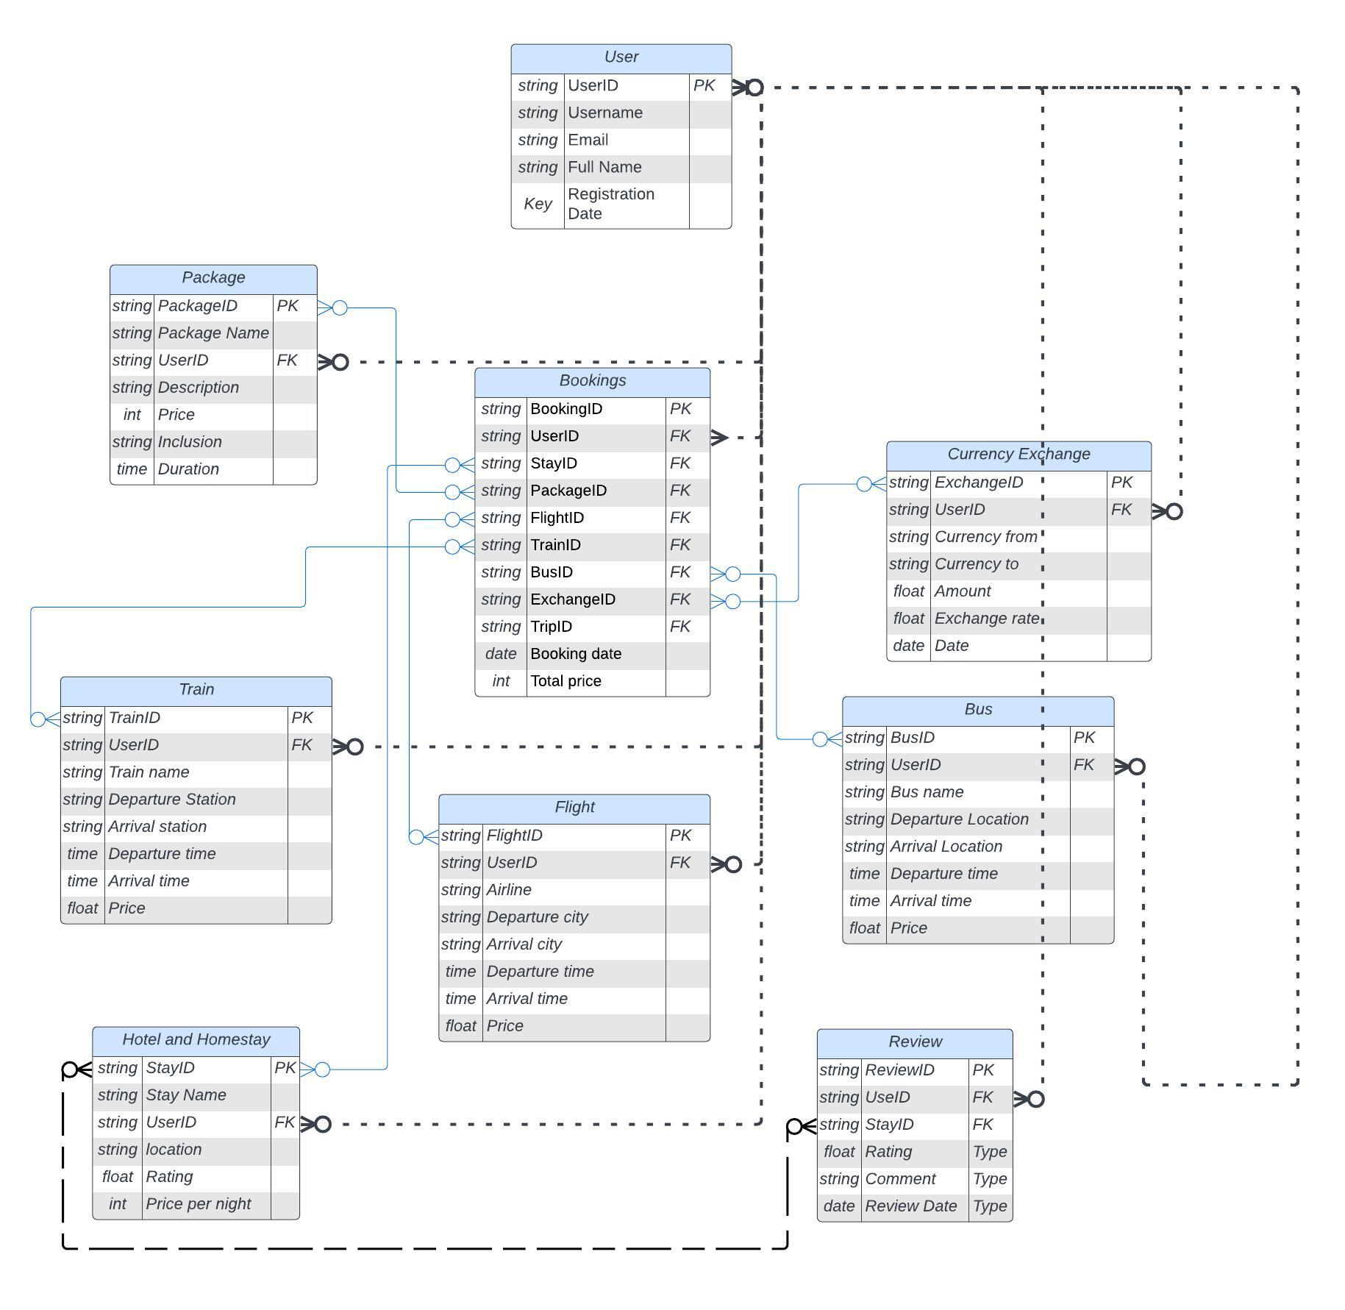

**Conclusion:**

MakeMyTrip's innovative approach to addressing real-world challenges in travel planning has positioned it as a leading online travel platform. By simplifying complex travel planning, ensuring price transparency, accommodating last-minute changes, and providing comprehensive destination exploration features, MakeMyTrip continues to enhance the travel experience for users. The schema and ER diagram presented here offer a structured view of the data model that underlies MakeMyTrip's seamless functionality, showcasing the platform's commitment to user-centric design and innovation in the travel industry.